Report

Entiol Liko

1.

Color histogram (10%)
To calculate the histogram of the specified part of the frame I have used the histogram function of np. For each color R, G, B I have calculated the histogram of the specifies part of the frame. The end result is a np list of 3 elements, where each element is the histogram for the red, green and blue color.

Derive Matrix A (5%)
  - no motion at all i.e. just noise
In this case we take into account only the previews position for x and y. For our calculation it means that the positions do not change seeing that we ignore the velocities. We have as the matrix A the following:
A =
  - constant velocity motion model
In this case we have to take into account the velocities as well. We have that the position in the next moment in time is going to be the sum of the old position and the old velocity, so X + V_x. For the y coordinate it is the same. In this case the matrix A changes from 2 by 2 to 4 by 4 seeing that we have 4 elements that we need to take into account. The new matrix is:
A =

Propagation (10%)
In this step we have to calculate the prediction based on the current state and on the matrix A. We have to add noise to this prediction where the variance for the position and velocity are specified by the params dictionary, which is an input to the program. In my implementation I start by specifying the matrix A and by generating random noise with the specified variance using numpy. After that the result is a simple matrix multiplication between the matrices of interest.

Observation (10%)
In this function we have to calculate the new weights based on the particles and the specified box. For each particle we calculate the histogram using the function specified above and after that we calculate the weight by using the formula given in the description of the assignment.

Estimation (5%)
This function was easy to implement seeing that it was pretty much a “dot product”. I used the functions offered by the numpy library.

Resampling (10%)
To implement this function I used the random.choice function provided by numpy to select elements from a set using as probabilities the weights provided to the function.

Experiments (50%)

video1.wmv (10%)
Exp. # | hist_{bin} | α | σ_{observe} | model | #particles | σ_{position} | σ_{velocity} | initial vel. |  | Observation
 |  |  |  |  |  |  |  | x | y | Observation
1 | 10 | 0 | 0.1 | 0 | 200 | 15 | - | - | - | Hand gets somewhat tracked but there is a lot of error
2 | 16 | 0.8 | 0.1 | 0 | 300 | 15 | - | - | - | Very good tracking with a bit of an error during the last 2 seconds.
3 | 10 | 0.6 | 0.1 | 1 | 200 | 10 | 0.1 | 2 | -5 | Successful but one frame behind.
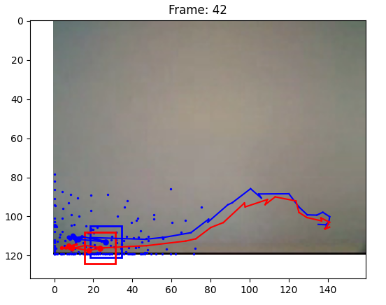
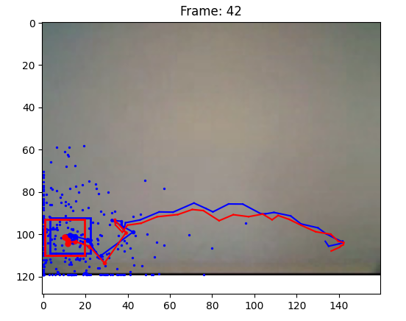

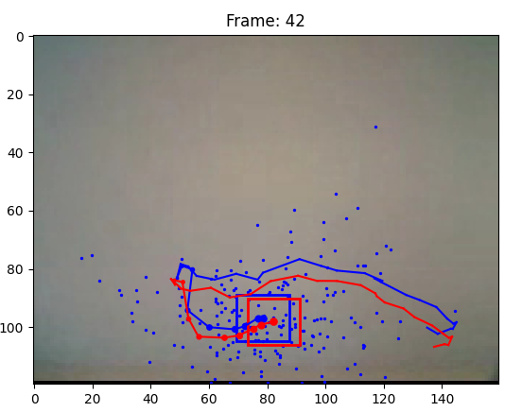

Conclusions
The hand can we tracked by tuning the parameters, so the code must be working as intended.

video2.wmv (20%)
I started the experiments with the best parameters from the previous video 1:
Exp. # | hist_{bin} | α | σ_{observe} | model | #particles | σ_{position} | σ_{velocity} | initial vel. |  | Observation
 |  |  |  |  |  |  |  | x | y | Observation
1 | 10 | 0.2 | 0.5 | 0 | 200 | 15 | - | - | - | Unsuccessful, sigma_observe too high
2 | 16 | 0.1 | 0.1 | 0 | 300 | 10 | - | - | - | Successful, 1 frame behind
3 | 16 | 0.2 | 0.2 | 1 | 300 | 10 | 0.1 | 3 | 0 | Successful up to the last 2 seconds

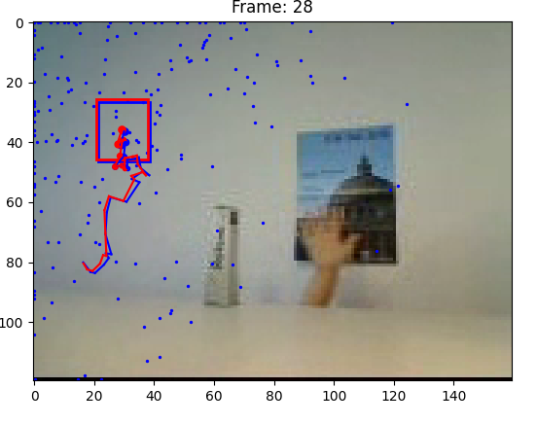
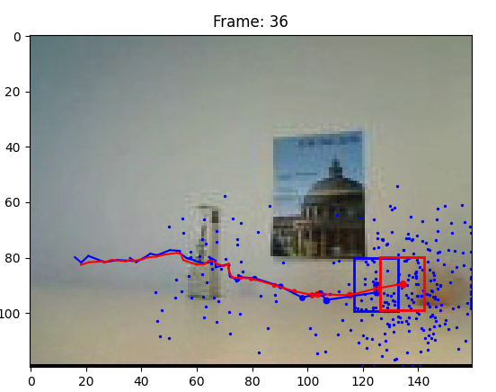

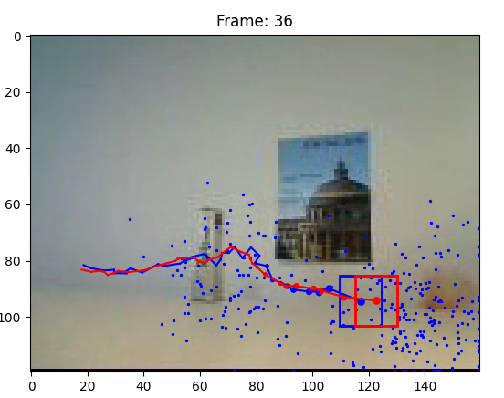

- What is the effect of using a constant velocity motion model?
From the experiments the change didn’t bring a lot of benefits to the prediction. The problem lies in the fact that the biggest change in the results are brought by other parameters. In the experiments I saw that the change in the variance of the noise, change number of points, the shape of the rectangle specified by the user were the biggest factors in the success or failure of the program.
- What is the effect of assuming decreased/increased system noise?
After the experiments I observed that a high or low system noise created problems for the detection. If the noise is to high the moment that the hand would be behind the object the box would move to a distant place. If the noise is too low the points are concentrated around the box and wouldn’t be able to “see” the hand show again on the right. I found that a value around 10 gave good results.
- What is the effect of assuming decreased/increased measurement noise?
The effects of the tuning of the measurement noise were less noticeable that those of the system noise. When I decreased the noise the results didn’t change a lot. If I lowered the noise we had lower variance and higher variance for increased noise. The problem is that we can “create” these effects by changing the system noise.

video3.wmv (20%)

 | hist_{bin} | α | σ_{observe} | model | #particles | σ_{position} | σ_{velocity} | initial vel. |  | Observation
 |  |  |  |  |  |  |  | x | y | Observation
1 | 10 | 0.2 | 0.1 | 0 | 300 | 15 | - | - | - | Unsuccessful
2 | 16 | 0.2 | 0.1 | 0 | 600 | 10 | - | - | - | Successful
3 | 10 | 0.5 | 0.1 | 1 | 300 | 10 | 1 | 5 | 0 | Successful

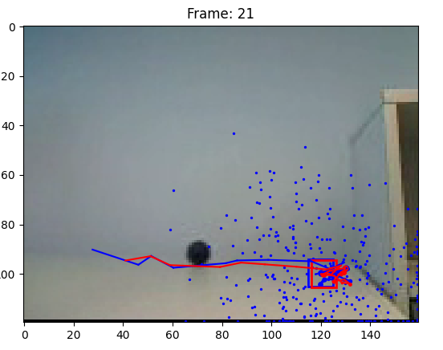
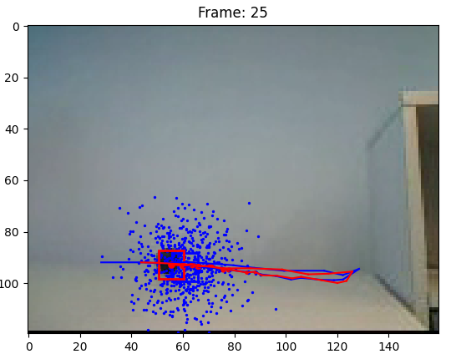

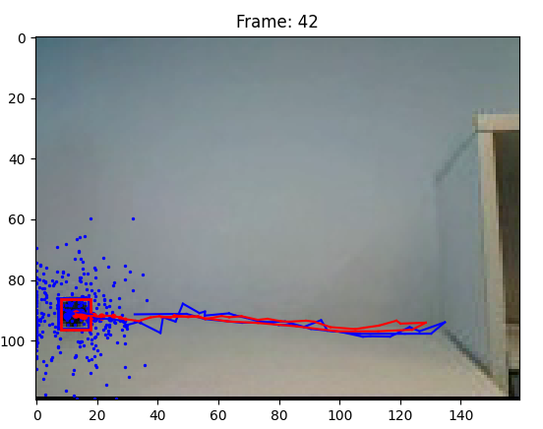

- Are you able to track the ball? Why or why not?
I am able to track the ball but the quality of the tracking depends heavily on the parameters used, most importantly on the numbers of particles and the value of alpha. Depending on the parameters the tracking may “block” on the right side of the scene where we have some black pixels and the tracker may mistake those pixels for the ball. It is important to find a suitable balance between the number of pixels and the other parameters.
- Consider the questions from point b) again, for video3.wmv. What are the effects for this video?
  - What is the effect of using a constant velocity motion model?
I had good results using the constant velocity model but I had to tune the other parameters. In some experiments where I used the model without velocity I had the position variance equal to 20 which modeled well the movement of the ball but If I use the constant velocity model with the same parameters I am unable to track the ball, a change to 10 for the variance of the position is necessary, after that the detector works as intended. The CVM can bring benefits but at the cost of retuning the other parameters.
  - What is the effect of assuming decreased/increased system noise?
In comparison to the second video in this case it turned out that decreasing the value of the noise increased the performance of the model. I think the reason for such behaviour is that the ball has little noise in its position, seeing that is moving on a surface there is no vertical movement so there is less noise than in the second video, where the hand passed behind an obstacle.
  - What is the effect of assuming decreased/increased measurement noise?
In my case a high measurement noise caused the detector to “distract” with other objects in the video, more specifically the shelf on the right where there are some black patches of pixels. I think the detector assumed these patches were the ball. Keeping a reasonably low noise level gave good results.

Further questions
- What is the effect of using more or fewer particles?
It has a different effect in the three videos. In the first video the effect is relatively low seeing that the hand is at all times in view. We don’t need a high number of points to keep track of the hand. If for a moment the tracker loses the position of the hand it can still be easily found seeing that it is always in view. There isn’t a real change in the results with more or fewer particles, assuming that we tune the other parameters.
In the second video the effects are very considerable. If the number of points is too low we lost track of the hand the moment it goes behind the obstacle. When the hand reappears it is not possible to re-find it because the points are not enough. The opposite effect can be seen when we increase the number of points. When the hand reappears it is easier to find it because we have enough points to sample in different positions. In this case the number of points is crucial to the success of the experiment.
The third video is similar to the first video. The object is moving with constant velocity in an horizontal surface. In this case, for similar reasons as in the first video, we have a small effect with the change of the number of particles. The most important factor in the success of the program are the other parameters.
- What is the effect of using more or fewer bins in the histogram color model?
In the testing that I did with the parameters of the program I didn’t notice any significant effect on the result. The increase or decrease of the number of bins had quite a low effect on the resulting performance. This is true for all 3 videos. I am unable to say with confidence the exact reason why this happens but the number of bins was a low importance parameter.
- What is the advantage/disadvantage of allowing appearance model updating?
As in the first question, here we have a different answer for each video. In the first video it helped because during the video the appearance of the hand changes. During the movement it rotates, the lighting changes and the shape changes as well.
In the second video the hand goes behind an obstacle so we need to be careful not to update the model too strongly because we could end up modeling the obstacle as well which would decrease the performance of the program.
In the third video the effects are less noticeable than in the first two videos and that is because we don0t have any obstacles and the shape, color and form of the ball does not change during the video so the value of alpha is a parameter with low importance in this case.

Conclusions
This specific implementation has good results in different scenes. The major problem is the dependency of the quality of detection to the parameters. Different values for the parameters are needed for different scenes, this means that this detector can’t be used as general purpose detector, but for the given scenes it seems to full fill its purpose.

